**Highlight a Checkbox**

The goal is to highlight the outline of certain checkboxes (not all checkboxes). Since Pega doesn't offer a direct way to highlight checkbox outlines, we need to create a custom CSS function and invoke it in the checkbox property.

There are two methods to accomplish this:

1. **Hardcoding the test ID**: We can assign a specific test ID to each checkbox and use this ID to style the checkbox. However, Pega does not recommend this approach as test IDs are intended for testing purposes and using them for styling might cause automation testing to fail.
2. **Defining a CSS function**: We can create a custom function and call it at the property level for each checkbox that requires an outlined highlight. This method aligns better with Pega's recommended practices.
3. **Hardcoding the test ID:**

We have to harcode the test id in the property level (checkbox) as shown below.

Then we have to write the custom css as shown below and call that css in harness level or skin level.

**CSS Code:**

[data-test-id="TestID"] {

outline: 1px auto blue; // identifies the test id in all the elements and highlights the checkbox

}

[data-test-id="TestID"]:focus {

outline: 1px auto blue !important; //identifies the test id in all the elements and highlights the checkbox when we focus on the checkbox

}

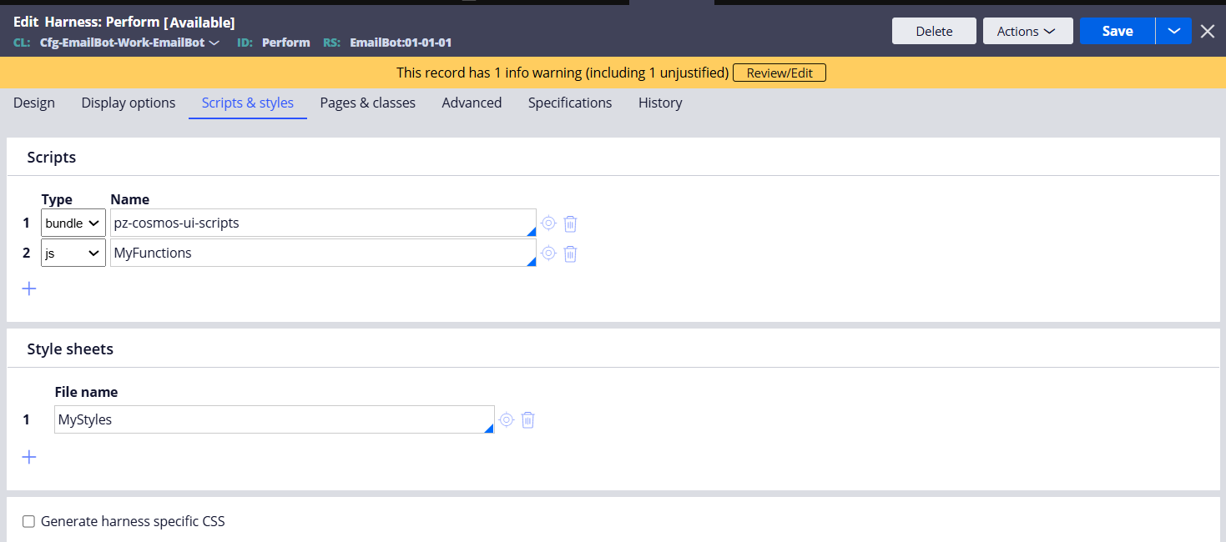

1. **Defining a CSS function**

This will be better approach then the above one.

We must write a custom function using css separators and call the function in the property level.

Css Code:

In the below code “RedHightlighter” is function which we need to call in checkbox property.

.RedHightlighter .checkbox is the css separator which will first identify the RedHightlighter div in all the elements and check for the checkbox input type.

!important will override the outline style which will define in other classes

.RedHightlighter .checkbox{

outline: 1px auto red !important;

}

.GreenHightlighter .checkbox{

outline: 1px auto green !important;

}

Call this sheet in the harness or skin, I used this sheet in harness level

Finally, we have to call the function in the property level as shown in the below.

Output:

Wherever the function referred the css will highlight the checkbox

I called two different functions for two checkboxes, and didn’t refer any function in three one.

We can resuse the same function in any checkbox level.